====================================

TASK 1 : BOOK OVERVIEW PAGE

====================================

Objective:

----------

Create a "Book Overview" webpage that introduces a book and outlines its contents.

Requirements:

-------------

- Use the following HTML tags: <h1>, <h2>, <p>, <img>, <ol>, <ul>

- Include:

- Book title (as a main heading)

- Cover image (with alt text)

- A short description of the book

- A nested list structure for chapters and sub-chapters:

- At least 3 chapters

- Each chapter must contain at least 2 sub-chapters

Bonus:

------

- Make your table of contents visually easy to follow using indentation

- Use meaningful names for chapters and sub-chapters

=============================================================

Task 2 : - Make the following table

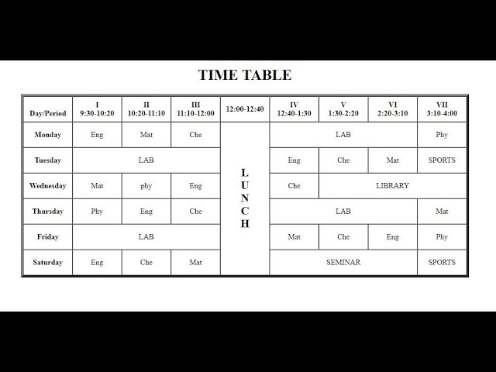

=================================================

Task 3 : - make the following form

